# DEPARTMENT OF

**ELECTRONICS AND COMMUNICATION ENGINEERING**

**Faculty of Engineering and Technology SRM Institute of Science and Technology**

MINI PROJECT REPORT

ODD Semester, 2020-21

Lab code and subject name: 18ECC203J and Microprocessor, Microcontroller and Interfacing techniques.

Year and semester : 3rd Year and 5th Sem

Project title : Counting Keypresses using 8086

Lab Supervisor : Mr. Prithiviraj R

Team Members : 1. Nithiya Nambi S – RA1811004010203

2. Muralidhar B – RA1811004010206

|  |  |  |
| --- | --- | --- |
| Reg. No | RA1811004010203 | RA1811004010206 |
| Mark split up |
| Novelty in the project work  (2 marks) |  |  |
| Level of understanding of the design formula (4 marks) |  |  |
| Contribution to the project  (2 Marks) |  |  |
| Report writing (2 Marks) |  |  |
| **Total (10 Marks)** |  |  |

# OBJECTIVE:

To count the number of keypresses, by accepting the input from the user.

# ABSTRACT:

The goal of the main program is to read the characters from the keyboard

buffer, place it on the screen, and to count the number of keypresses done by the user.

# INTRODUCTION:

Almost all computers need to operate with external devices. At the very least, you need to use the keyboard, the screen, and the disk drive. Device drivers are code that operate these devices and provide a layer of abstraction between the operating system and the device. That way, as long as the device driver provides certain functions that are well-defined, the operating system does not have to know how the device driver is implement.

# SOFTWARE REQUIRED:

EMU 8086

**BLOCK DIAGRAM:**

**8086**

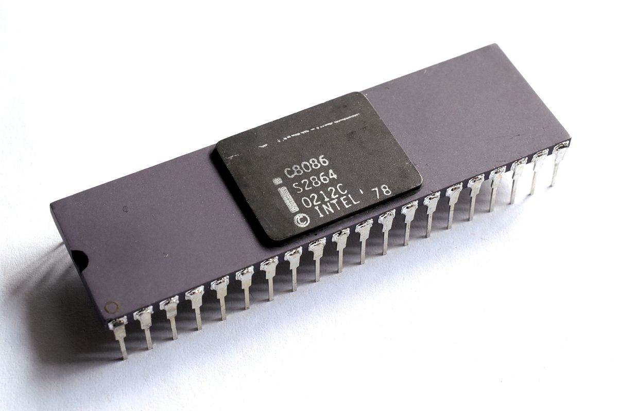

**Keyboard Input**

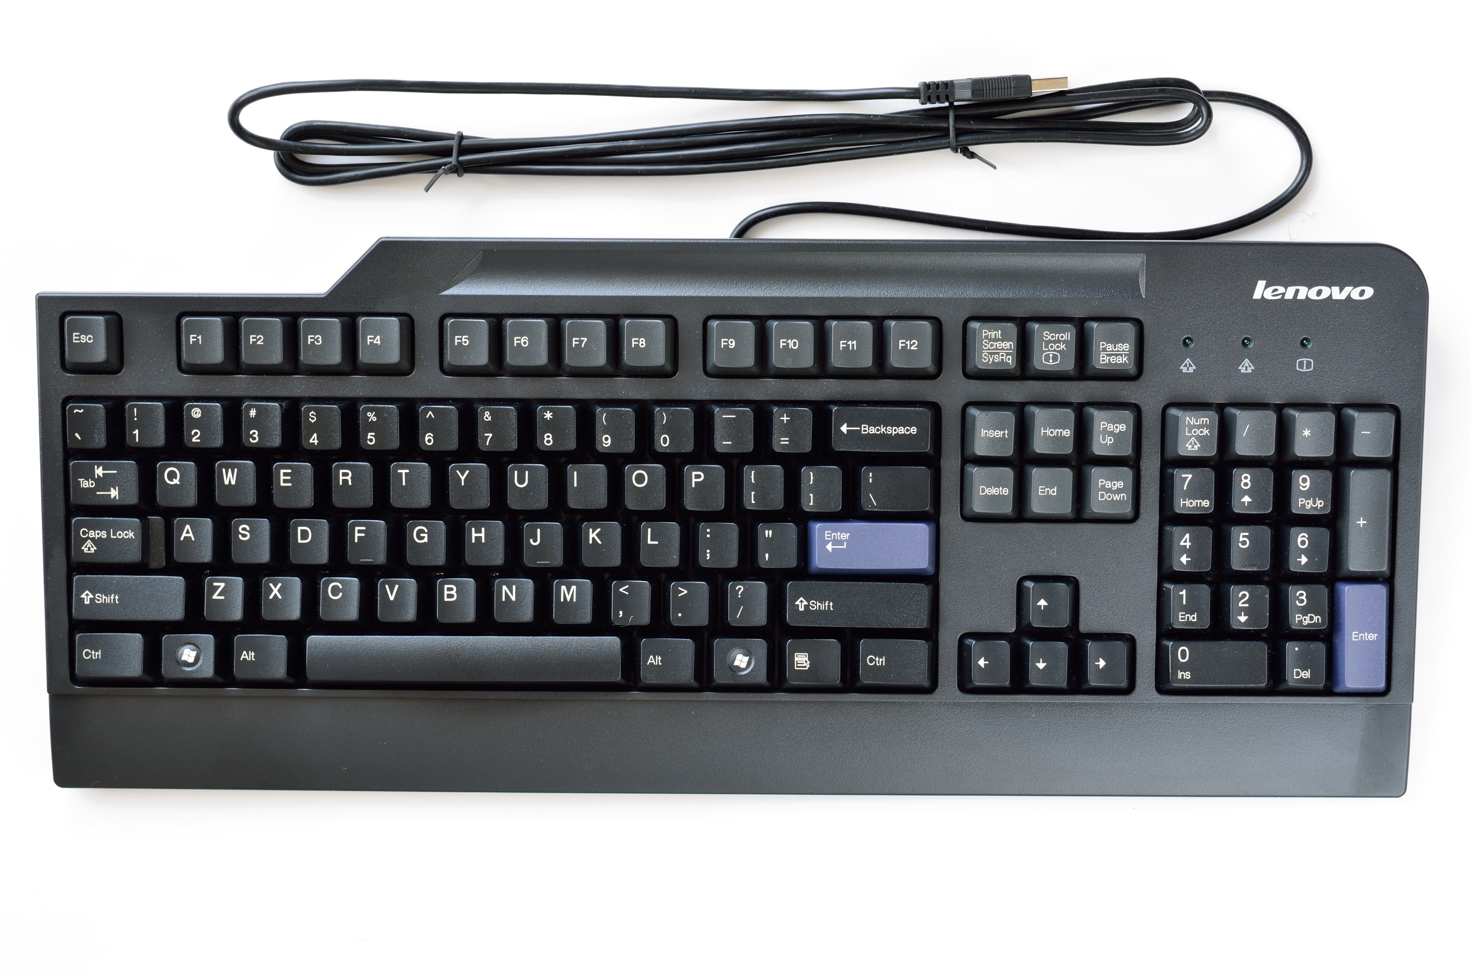

# 

# 

# The purpose of the program is to count the key presses from the keyboard. So the input hardware device is the keyboard, which sends the input to 8086 microcontroller. The keypresses are stored in the BX register of 8086, which is incremented every time input from keyboard is received (apart from esc key), while the input from keyboard is stored in the AH register, and is printed in the emulator screen when input is received.

# PROGRAM:

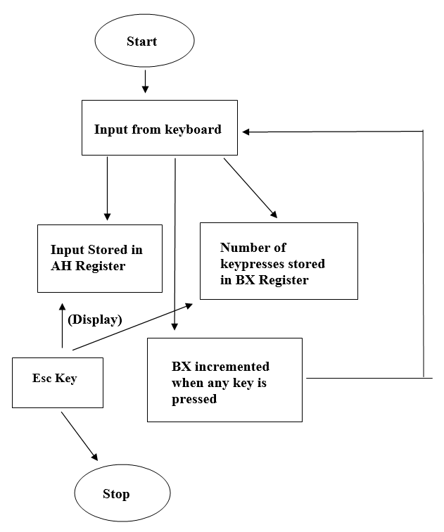

; Count number of key presses. the result is in bx register.

; You must type into the emulator's screen,

; if it closes, press screen button to re-open it. name "keycount"

org 100h

; print welcome message: mov dx, offset msg

mov ah, 9 int 21h

xor bx, bx ; zero bx register.

wait: mov ah, 0 ; wait for any key....

int 16h

cmp al, 27 ; if key is 'esc' then exit. je stop

mov ah, 0eh ; print it. int 10h

inc bx ; increase bx on every key press. jmp wait

; print result message:

stop: mov dx, offset msg2 mov ah, 9

int 21h

mov ax, bx call print_ax

; wait for any key press:

mov ah, 0 int 16h

ret ; exit to operating system.

msg db "I'll count all your keypresses. press 'Esc' to stop ", 0Dh,0Ah, "$"

msg2 db 0Dh,0Ah, "recorded keypresses: $"

print_ax proc cmp ax, 0

jne print_ax_r push ax

mov al, '0' mov ah, 0eh int 10h

pop ax ret

print_ax_r: pusha mov dx, 0

cmp ax, 0 je pn_done mov bx, 10 div bx

call print_ax_r mov ax, dx add al, 30h mov ah, 0eh int 10h

jmp pn_done pn_done:

popa ret

endp

# OUTPUT:

SIMULATION OUTPUT:

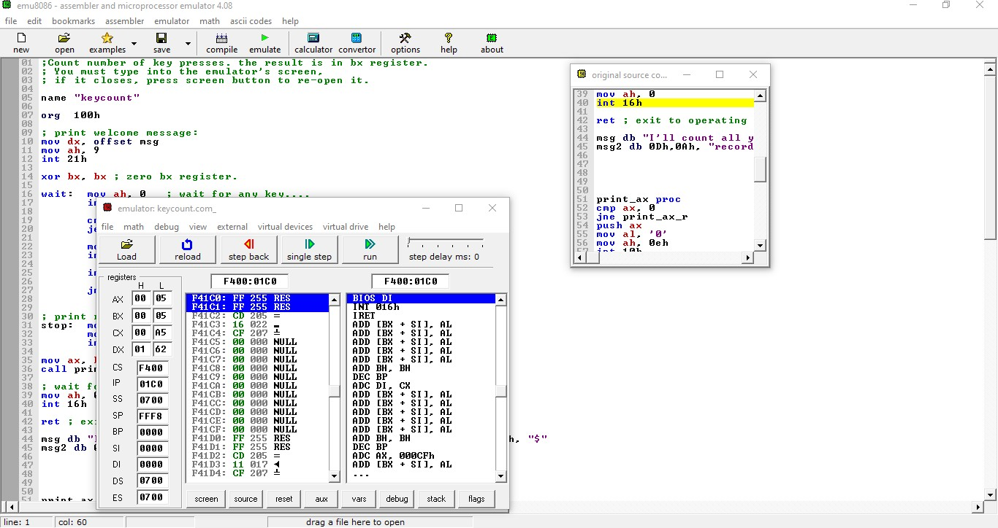

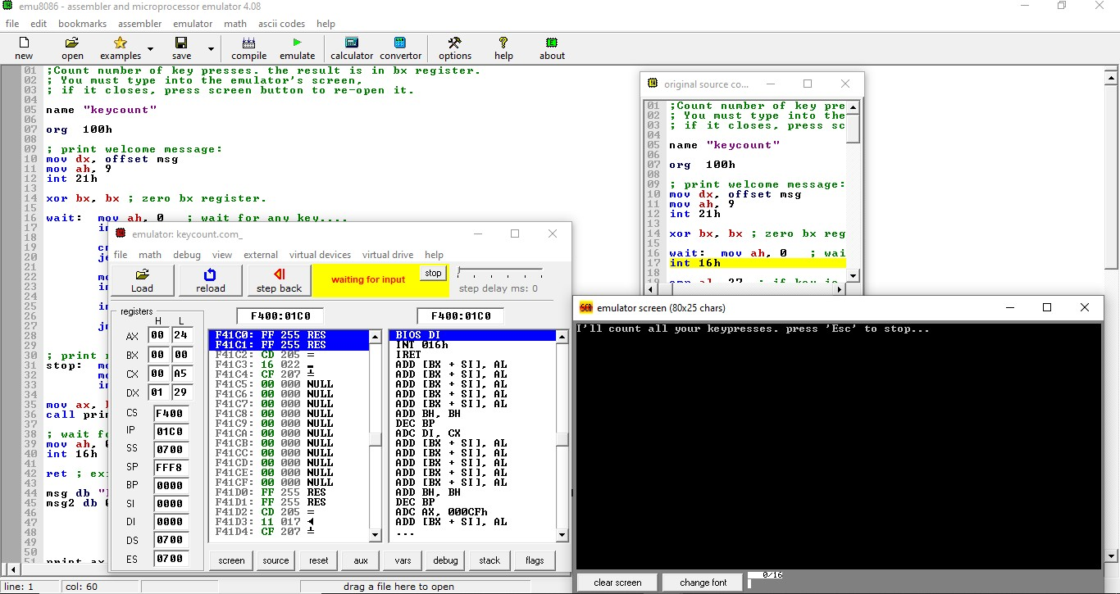

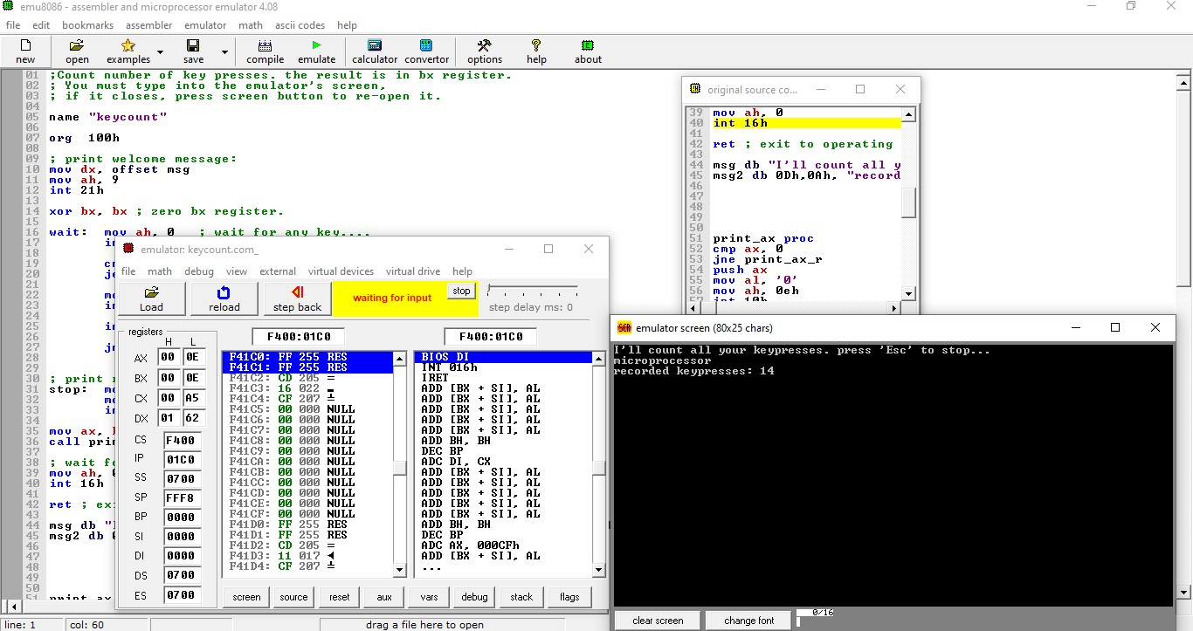

# CONCLUSION:

Thus, using 8086 and taking input from keyboard, the number of keypresses were successfully counted.